Petclinic
performance Test Summary Report
Version 0.8
20/12/2018

VERSION HISTORY
Version # | Implemented  By | Revision  Date | Approved  By | Approval  Date | Reason
0.8 | Christopher Wesemael | 20/12/2018 | Chester Gardner | 20/12/2018 | Initial Structure outline
0.9 | Zak Roberts | 20/12/2018 | Chester Gardner | 20/12/2018 | Completed test results added
Latest Version: 20/12/2018

TABLE OF CONTENTS
1 Introduction 5
1.1 Purpose 5
2 Test Summary 5
3 Tests 5
4 Test Results 5
5 REcommended aCTIONS 6
Appendix A: Test Summary Report Approval 7

Introduction

Purpose
This PetClinic Test Report provides a summary of the results of test performed as outlined within this document.

Specifically targeted at the performance of the system.

2 Test Summary
Testing of the system to evaluate the quality and capability of the product under varying levels of load. Essentially how the system performs in terms of responsiveness and stability under the different levels of load.
Project Name: Pet Clinic Testing Assignment
System Name: PetClinic
Version Number: 1.0
Primary Testers: Chester Gardner, Zak Roberts.

3 Tests
Module | Desciption | Expected Result | Actual result | passed | Signed off
Owner | GET owner list – load test | System handles all traffic without failures | System failed with large amount of users | NO | CG
Owner | GET owner list – spike test | System handles all traffic without failures | System failed with large spike in users | NO | CG
Pet | GET pet list – load test | System handles all traffic without failures | System failed with large amount of users | NO | CG
Pet | GET pet list – spike test | System handles all traffic without failures | System failed with large spike in users | NO | CG
Pet-Type | GET pet-type list – load test | System handles all traffic without failures | System failed with large amount of users | NO | CG
Pet-Type | GET pet-type list – spike test | System handles all traffic without failures | System failed with large spike in users | NO | CG
Specialty | GET specialty list – load test | System handles all traffic without failures | System failed with large amount of users | NO | CG
Specialty | GET specialty list – spike test | System handles all traffic without failures | System failed with large spike in users | NO | CG
Vet | GET vet list – load test | System handles all traffic without failures | System failed with large amount of users | NO | CG
Vet | GET vet list – spike test | System handles all traffic without failures | System failed with large spike in users | NO | CG
Visit | GET visit list – load test | System handles all traffic without failures | System failed with large amount of users | NO | CG
Visit | GET visit list – spike test | System handles all traffic without failures | System failed with large spike in users | NO | CG

4. Test Results

The following test results were designed in accordance with the business’ requirement of expected growth for the first quarter of 2019.
The load tests undertaken here looked at how the system performed when 100 users were loaded on to the system over a given period of time. This load of users is prolonged for a number of seconds, to see if the system can handle keeping many users active.
The spike tests added 100 users in a much shorter timeframe but without holding the load. It mainly shows how the system recovers from being heavily loaded in a short period.

Owner
For this module, the list of pet owners within the PetClinic database was fetched from the system.
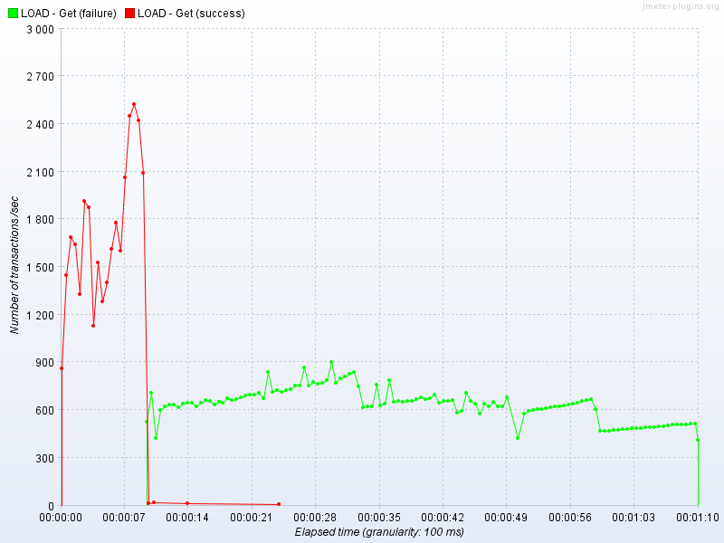

The above graph shows how the number of transactions (a request to a system, how the owners list is retrieved) over the elapsed time during the load test. It shows a degradation of performance causing a system failure at 500 transactions per second, which is early on in the system’s use.

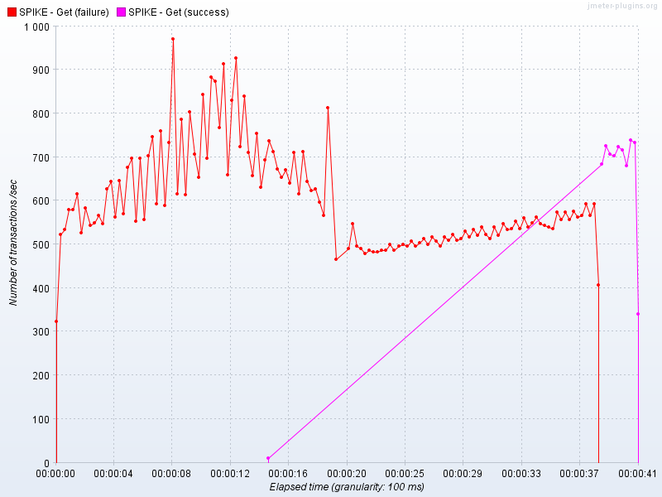

This graph above shows the spike test performance, showing how the system quickly fails as lots of users are added in a short space of time. The successes close to the end shows the system successfully recovers from the immense load, which is very positive.

Pet
For this module, the list of pets within the PetClinic database was fetched from the system.
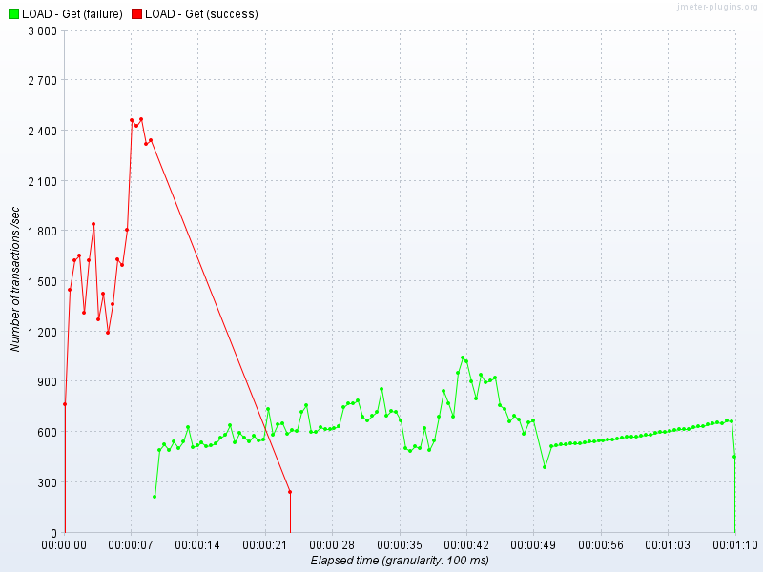

The above graph shows how the number of transactions (a request to a system, how the owners list is retrieved) over the elapsed time during the load test. It shows a degradation of performance causing a system failure at 1800 transactions per second, which is early on in the system’s use.

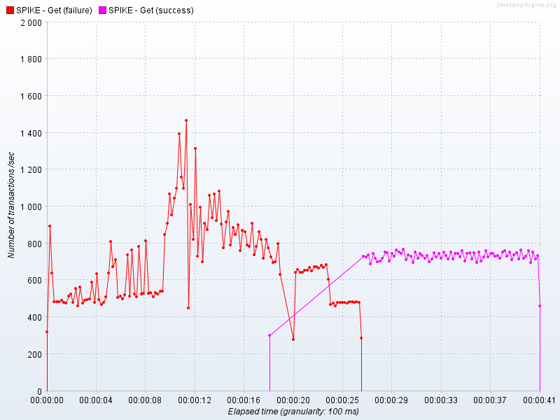

This graph above shows the spike test performance, showing how the system quickly fails as lots of users are added in a short space of time. The successes close to the end shows the system successfully recovers from the immense load, which is very positive.

Pet-Type
This module fetches the list of pet types from the PetClinic database.

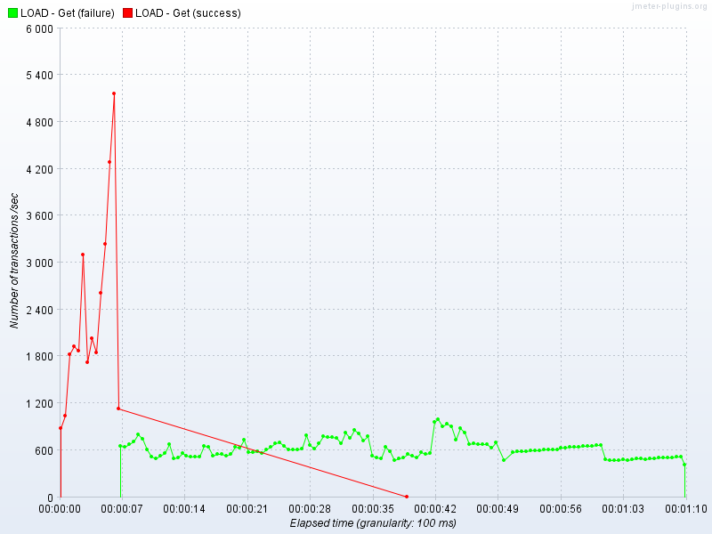

The above graph shows how the number of transactions (a request to a system, how the owners list is retrieved) over the elapsed time during the load test. It shows a degradation of performance causing a system failure at 2000 transactions per second, which is early on in the system’s use.

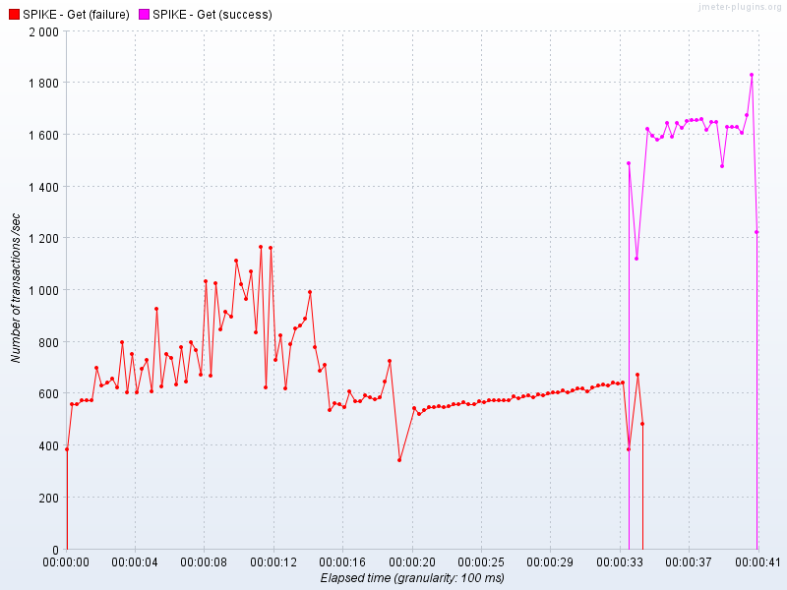

This graph above shows the spike test performance, showing how the system quickly fails as lots of users are added in a short space of time. The successes close to the end shows the system successfully recovers from the immense load, which is very positive.

Specialty
This module shows the specialties of the vets in the PetClinic database, with the tests fetching these as a list.

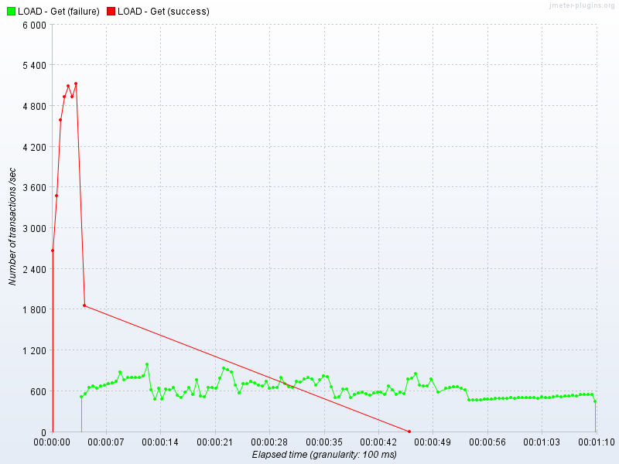

The above graph shows how the number of transactions (a request to a system, how the owners list is retrieved) over the elapsed time during the load test. It shows a degradation of performance causing a system failure at 4000 transactions per second, which is early on in the system’s use.

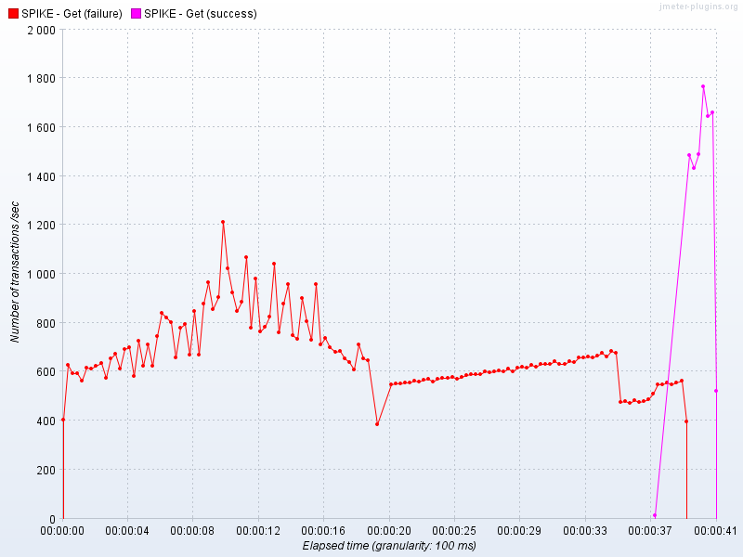

This graph above shows the spike test performance, showing how the system quickly fails as lots of users are added in a short space of time. The successes close to the end shows the system successfully recovers from the immense load, which is very positive.

Vet
These tests fetched a list of vets at PetClinic.

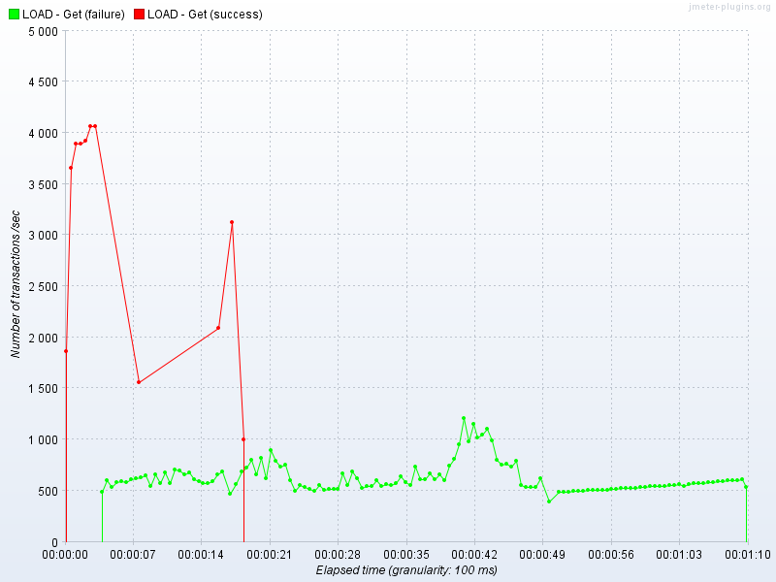

The above graph shows how the number of transactions (a request to a system, how the owners list is retrieved) over the elapsed time during the load test. It shows a degradation of performance causing a system failure at 4000 transactions per second, which is early on in the system’s use.

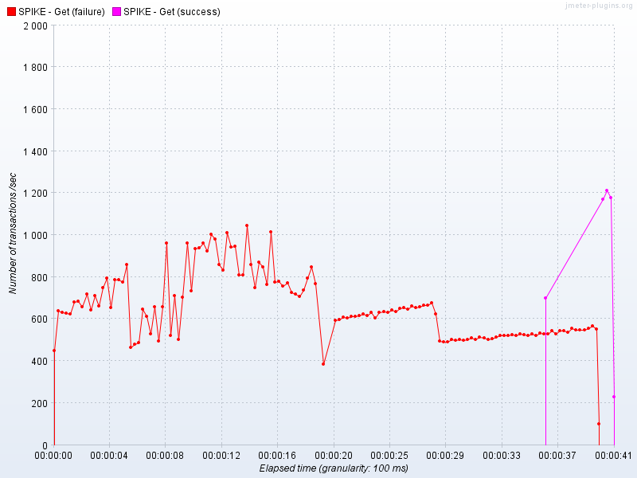

This graph above shows the spike test performance, showing how the system quickly fails as lots of users are added in a short space of time. The successes close to the end shows the system successfully recovers from the immense load, which is very positive.

Visit
Here we fetch the list of visits for pets to the PetClinic.

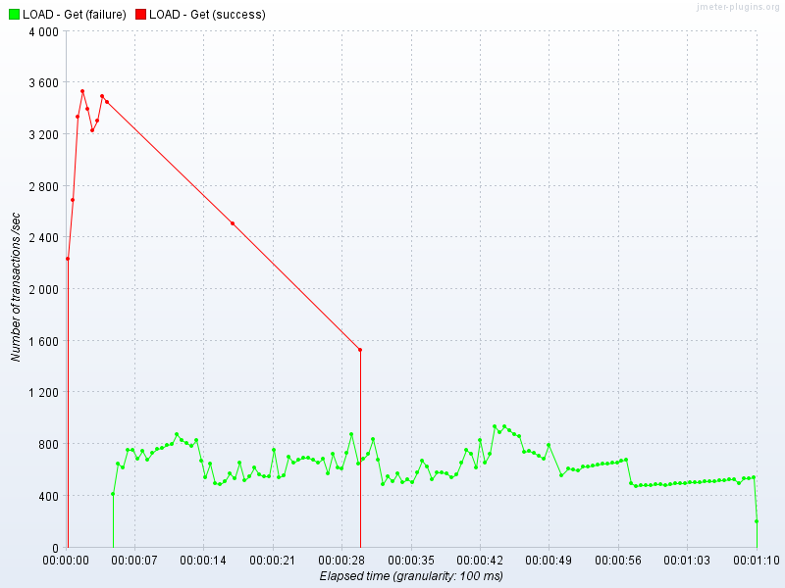

The above graph shows how the number of transactions (a request to a system, how the owners list is retrieved) over the elapsed time during the load test. It shows a degradation of performance causing a system failure at 4000 transactions per second, which is early on in the system’s use.

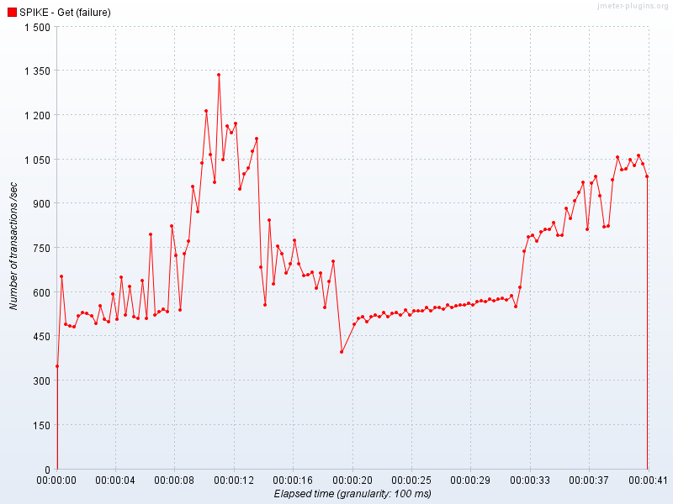

This graph above shows the spike test performance, showing how the system quickly fails as lots of users are added in a short space of time. The system unfortunately does not recover immediately, but would do given a longer time to do so.

Recomendations

Based on the poor system performance under heavy load, environment upgrades or configuration changes are needed, along with further testing. Therefore, the go-live decision is not recommended at this time with the current system build.
Appendix A: Test Summary Report Approval
The undersigned acknowledge they have reviewed the PetClinic Test Summary Report and agree with the approach it presents. Changes to this Test Summary Report will be coordinated with and approved by the undersigned or their designated representatives.
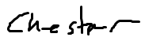
Signature: |  | Date: | 20/12/2018
Print Name: | Chester Gardner
Title: | Consultant
Role: | Test Lead

